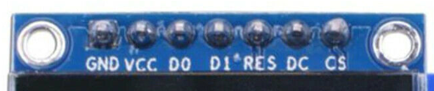
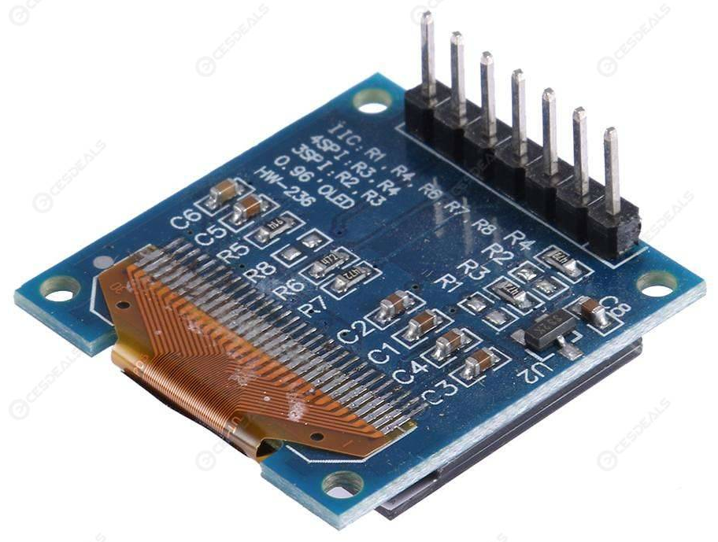

Shipped as: 4SPI (with R3, R4 connected)

https://cdn-shop.adafruit.com/datasheets/SSD1306.pdf
8.1.3 MCU Serial Interface (4-wire SPI)
The 4-wire serial interface consists of serial clock: SCLK, serial data: SDIN, D/C#, CS#. In 4-wire SPI mode, D0 acts as SCLK, D1 acts as SDIN. For the unused data pins, D2 should be left open. The pins from D3 to D7, E and R/W# (WR#)# can be connected to an external ground.
Table 8-4 : Control pins of 4-wire Serial interface
Function | E(RD#) | R/W#(WR#) | CS# | D/C# | D0
Write command | Tie LOW | Tie LOW | L | L | ↑
Write data | Tie LOW | Tie LOW | L | H | ↑

SDIN is shifted into an 8-bit shift register on every rising edge of SCLK in the order of D7, D6,... D0. D/C# is sampled on every eighth clock and the data byte in the shift register is written to the Graphic Display Data RAM (GDDRAM) or command register in the same clock. Under serial mode, only write operations are allowed.
Figure 8-5 : Write procedure in 4-wire Serial interface mode
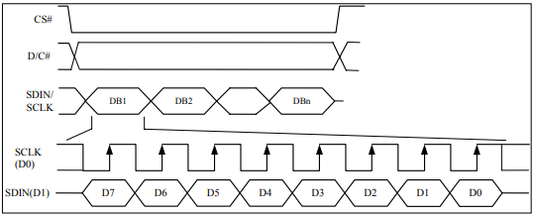

- GND goes to ground
- Vin goes to 5V
- SDATA to digital 9
- SCLK to digital 10
- D/C# to digital 11
- RST to digital 8
- CS to digital 12
(Note: If using the display with other SPI devices, D/C, CLK and DAT may be shared, but CS must be unique for each device.)

The actual pin labels on the OLED are connected as follows for 4 wire SPI:
OLED Label | OLED SPI Mode Signal Name | Arduino UNO pin connection
GND | Ground | GND
VCC | +3.3 VDC | 3.3 VDC
DO | SCLK | D10
D1 | SDIN | D9
RES | RST | D8
DC | D/C# | D11
CS | CS | D12

Note: Oct. 20, 2019 – Move the OLED reset pin to UNO D8. Originally used D13 but that kept the onboard LED permanently on and it annoyed me.

